‘Dark Blade 2019’ successfully completed

Náměšť airbase, Czech Republic - 07 June, 2019

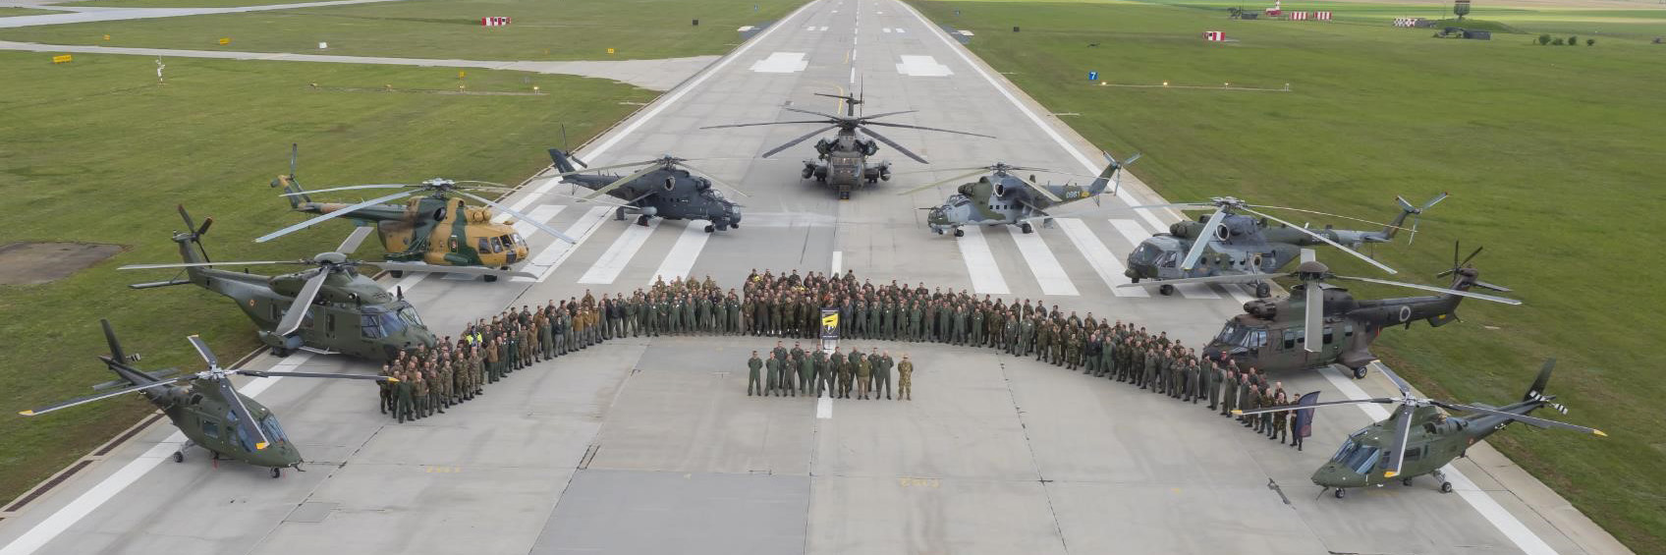

**Dark Blade 2019, already the 13th multinational training organised under EDA’s Helicopter Exercise Programme (HEP), was successfully completed last week at Náměšť airbase in the Czech Republic.**

A total of 29 air assets from Belgium (3 A-109 and 3 NH-90), Czech Republic (5 Mi-24, 6 Mi-171 and 4 L-159 “Alca”), Germany (3 CH-53), Hungary (3 Mi-24 and 2 Mi-27), Slovenia (1 AS-532) and Poland (1 W-3A) were involved in the exercise, as well as around 1,200 military staff. Observers from Serbia, the Netherlands, Sweden and the Joint Air Power Competence Centre (JAPCC) also attended. Furthermore, a multinational Joint Tactical Air Controller (JTAC) team and an Electronic Warfare (EW) emulator system were also involved. A mentor team encompassing helicopter tactics instructors from Austria, Sweden, the Netherlands and the UK supported the academic part of the exercise and provided mentoring and standardisation during the planning and execution phases of all Composite Air Operations (COMAO) missions.

The main objective of DB19 was the performance of 8 day/night COMAO missions in a realistic, harsh and complex environment, as well as to carry out specific training as evasion training, live firing, formation flights, paratrooper and scuba jumps, rappelling and fast roping. In total, some 290 flights were performed amounting to around 500 flight hours.

A Distinguished Visitors Day was organized on 28 May, attended by Czech Defence Minister Lubomir Metnar, the President of the Czech Senate, Jaroslav Kubera, as well as other military and civilian authorities.

During the closing ceremony on 30 May, EDA’s Project Officer Rotary Wing, José Pablo Romera, thanked the Czech Air Force, and in particular 22nd HAB Náměšť Airbase Commander, Col Miroslav Svoboda and all his team, for the outstanding organisation and execution of the exercise. A special thanks also went to all the participants for their proactive involvement and cooperative mindset which resulted in the achievement of the expected training objectives.

The next EDA helicopter exercise, ‘Swift Blade 2020’, will take place in April 2020 and will be jointly hosted by The Netherlands and Belgium, with Gilze-Rijen Air Base as the main location.

Background

A decade ago, the multinational helicopter training cooperation started in EDA with the aim of improving the European helicopter operational capability for crisis management operations and prepare helicopter crews for deployments by providing them advanced helicopter tactics training. Over time, requirements related to interoperability and training standardisation have been added to ensure that training does not only improve national readiness, but also supports multinational cooperation.

Since 2009, 13 Blade exercises held in eight different European countries (France, Spain, Italy, Belgium, Portugal, Finland, Hungary and Czech Republic), 9 helicopter tactics symposiums, 63 Helicopter Tactics Courses, 6 Helicopter Tactics Instructors Courses and several other training activities, as COMAO planning courses and the EW courses have been carried out under EDA management and involving 15 EDA Member States.

The outcome of all those trainings is a high level of operational interoperability and helicopter cooperation among a large number of EDA member states. The next important step will be the transfer of all those activities and programmes (HEP, HTC and HTIC) to a future Multinational Helicopter Training Centre (MHTC) by end of 2021.